Conjunction

🟢 What is a Conjunction?
# Source: Chatgpt (GPT-4-turbo) at [7/24/2025]
A conjunction is a word used to connect words, phrases, or clauses.
It helps link ideas and shows the relationship between them — such as addition, contrast, or cause.

📘 Definition:
# Source: Chatgpt (GPT-4-turbo) at [7/24/2025]
A conjunction is a word that joins two or more words, phrases, or clauses in a sentence.

🧠 Common Conjunctions:
# Source: Chatgpt (GPT-4-turbo) at [7/24/2025]
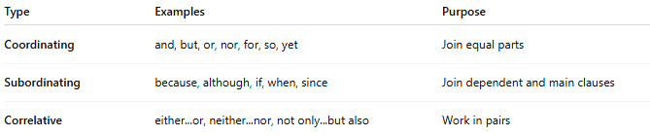
Type | Examples | Purpose
Coordinating | and, but, or, nor, for, so, yet | Join equal parts
Subordinating | because, although, if, when, since | Join dependent and main clauses
Correlative | either...or, neither...nor, not only...but also | Work in pairs

✳️ Examples in Sentences:

🟩 Coordinating Conjunctions (FANBOYS: for, and, nor, but, or, yet, so)
# Source: Chatgpt (GPT-4-turbo) at [7/24/2025]
- I like tea and coffee.
- He is tired, but he still works.
- You can have juice or soda.

🟨 Subordinating Conjunctions
# Source: Chatgpt (GPT-4-turbo) at [7/24/2025]
- I stayed home because it was raining.
- Although he was late, he finished the test.
- Call me when you arrive.

🟦 Correlative Conjunctions
# Source: Chatgpt (GPT-4-turbo) at [7/24/2025]
- Either you apologize or you leave.
- Not only is she smart, but also kind.
- Neither the teacher nor the students were ready.

✅ Summary:
# Source: Chatgpt (GPT-4-turbo) at [7/24/2025]
A conjunction is a word that connects words, phrases, or clauses.
It helps you combine ideas clearly and logically.

